Name________________ Date______________

Final Projects for Maniac Magee by Jerry Spinelli

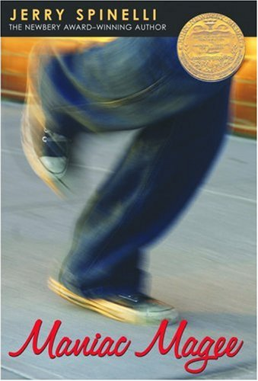
- Due Friday, May 30, 2013
- You will work on these projects in class and for homework
- Please read all of the project options and choose one by tomorrow, Thursday, May 16th.
- Please KEEP THIS PACKAGE in your homework folder.

_______________________________________________________________________________________

Project Timeline:

Check the boxes as you complete each stage.

Thursday, May 15th- Choose a project from the list below and highlight the important requirements on the pages attached.

Wednesday May 21st – At least half of your rough draft completed as well as a sketch of your visual components

Friday May 23rd – Your visual images completed

Wednesday May 28th – Your full rough draft ready to hand in for corrections

Friday May 30th-Good copy and all images ready to hand in

Maniac Magee Project Choices
_________________________________________________________
- Write an alternate ending for Maniac Magee. (Three single-spaced typed pages in your own words).
Include:
- A book cover with a bold title and an illustration.
- The author’s name as well as your own on the front cover
- One colourful illustration or printed image within the body of your chapter
Choose one of the following:
- Near the end of the book, Mars Bar offers to let Maniac live with him and Maniac refuses. Then, Amanda orders him home with her and he accepts. Write an alternate ending to the novel in which Maniac chooses to live with Mars Bar instead of Amanda. Have Maniac explain the reasons for his choice to Amanda. Include character descriptions so that someone who had not read the rest of the book would understand the characters.

- Maniac Magee has a happy ending in which Maniac finally finds a home. Using the same writing style and point of view as Jerry Spinelli uses in Maniac Magee, re-write Chapter 46 to make it a sad or tragic ending. Include character descriptions so that someone who had not read the rest of the book would understand the characters. Make it believable.

- An Interview
Maniac Magee ends with many questions still unanswered. Imagine ten years have passed from the time the novel ends. Write an interview script in which Maniac answers these questions. Include an opening, 20 thoughtful questions with detailed answers and a satisfying conclusion.
Include:
- A cover page with a bold title and an illustration.
- The author’s name as well as your own on the front cover
- One colourful illustration or printed image within the body of your chapter

- Power Point Presentation
Critics have classified Maniac Magee as realistic fiction, legend, a morality play, and part myth. Research the characteristics of each of these types of literature, and decide how you would classify the book. Write and present a five minute presentation arguing that Maniac Magee falls into the category you have chosen. Support your answer with specific references to the book. Present your opinion to the class in a persuasive and engaging way. Hand in a script of what you will say as you show each slide during your presentation. Present to the class on May 30th.
Include:
- A cover for your script with a bold title and an illustration.
- The author’s name as well as your own on the front cover
- One colourful illustration or printed image within the body of your script

- Make a poetry book based on Maniac Magee. Research the following literary devices and use them in your project:

Metaphor, Simile, Personification, Onomatopoeia, Repetition, Rhyme, Rhythm
and Alliteration
Using two examples of each of the literary devices listed above, make a book of 10 poems inspired by 10 different chapters in Maniac Magee. In order to include two examples of each literary device, you may use direct quotes from the novel in your poetry and make up your own original metaphors, similes, and other poetic devices. Please underline each example. Your poetry book must include:
- An illustrated cover with a unique title
- An index
- 10 original poems
- At least one image within the body of your poetry book
- A glossary of the poetic terms listed above (with definitions)

- Make a board game about the book of Maniac Magee.
Your game should include:
- A bright, colourful game board made to look like Two Mills
- Ten different labelled locations from the book. Poster board will be provided for you.
- Four to six game pieces
- Dice (or a spinner)
- 20 cards with typed instructions. Cards will tell the players what to do based on the events from the novel. Include details from the novel on every card. Example1: Grayson passes away in the night leaving Maniac alone again. The men who come to bury Grayson show disrespect by smoking at the grave site and the minister is late. Go back four spaces. Example 2: Maniac hits John McNab’s frog ball and destroys John’s record. The crowd is amazed and excited because no one has ever been able to hit one of John’s pitches. Maniac’s fame grows. Move ahead two spaces.

Remember to proofread and edit before handing in your rough draft.
Refer to your rubric as you go and self evaluate.
Good luck and have fun!

